Software Design Document

for

PlasmaGraph

Version 0-2014-05-10

|  |  |  |
| --- | --- | --- |
| Daniel E. Quintini |  | Gerardo A. Navas |
| Computer Science Undergraduate Program |  | Computer Science Undergraduate Program |

Polytechnic University of Puerto Rico

May 10, 2014

Revision History

|  |  |  |
| --- | --- | --- |
| **Date** | **Version** | **Reason For Changes** |
| January 21, 2014 | 0-01-21-2014 | First version of document. No diagrams, just Introduction. Using SPMP as template. |
| January 23, 2014 | 1-02-23-2014 | Second version of document; added diagrams made up to this date. Provided better structure and removed all mentions of SPMP, including Table of Contents. |
| May 22, 2014 | 1-05-22-2014 |  |

Table of Contents

1. INTRODUCTION 1

1.1 Purpose 1

1.2 Scope 1

1.3 Overview 1

1.4 Reference Material 1

1.5 Definitions and Acronyms 2

2. SYSTEM OVERVIEW 2

3. SYSTEM ARCHITECTURE 4

3.1 Architectural Design 4

3.2 Decomposition Description 4

3.3 Design Rationale 4

4. DATA DESIGN 5

4.1 Data Description 5

4.2 Data Dictionary 5

5. COMPONENT DESIGN 7

6. HUMAN INTERFACE DESIGN 8

6.1 Overview of User Interface 8

6.2 Screen Images 8

6.3 Screen Objects and Actions 9

7. REQUIREMENTS MATRIX 10

8. APPENDICES 11

List of Figures

List of Tables

**No table of figures entries found.**

# 1. INTRODUCTION

## 1.1 Purpose

This document, the Software Design Document, is designed to describe the architectural and system details of the PlasmaGraph product to all whom are interested in understanding the design decisions made in the creation of this product; specifically, this document is made for the students working at the Polytechnic University of Puerto Rico's Plasma Laboratory and any future contributors to the PlasmaGraph project. It explains what the program does and why it does it in order to provide an accurate synopsis of how the functional and non-functional requirements are achieved. Diagrams and pseudo-code will be both used in order to appropriately and concisely detail how PlasmaGraph will satisfy the requirements listed in the System Requirement Specifcation (SRS) document. In doing so, readers will obtain a close-to-exact idea of how the program will function without having to look at the code itself.

## 1.2 Scope

The project, currently by the Plasma Visualization Group, is designed to create a product called PlasmaGraph. PlasmaGraph is a graphing solution specifically made to create graphs from the PUPR Plasma Laboratory's Matlab-encoded data files. It allows the user to select the matlab-encoded data file to use, select the graphs columns and other visual settings, generate regressions based on one or more groups of data, and save the resulting graphs. PlasmaGraph is to be used at the end of the experiment analysis pipeline of the Plasma Laboratory in order to visualize experiment data tendencies without resorting to tools that require programming knowledge, such as Matlab. This product would, therefore, be indispensable to both new members of the Plasma Laboratory work team and older members who want to quickly view and understand experiment data.

## 1.3 Overview

The SDD is divided into various sections, each emphasizing an aspect of the product.

[TBD]

## 1.4. Reference Materials

|  |  |
| --- | --- |
| [1] | Object Refinery Limited, "JFreeChart," Object Refinery Limited, 25 November 2013. [Online]. Available: http://www.jfree.org/jfreechart/. [Accessed 13 May 2014]. |
| [2] | The MathWorks, Inc., "MATLAB - The Language of Technical Computing," [Online]. Available: http://www.mathworks.com/products/matlab/?s_tid=hp_fp_ml. [Accessed 12 May 2014]. |
| [3] | Oracle Corporation, "What is Java and why do I need it?," 25 March 2014. [Online]. Available: http://www.java.com/en/download/faq/whatis_java.xml. [Accessed 13 May 2014]. |
| [4] | Merriam-Webster, "Dictionary and Thesaurus - Merriam-Webster Online," [Online]. Available: http://www.merriam-webster.com/. [Accessed 12 May 2014]. |
| [5] | B. Goines, S. Chacon and M. McCullough, "Git - About Version Control," [Online]. Available: http://git-scm.com/book/en/Getting-Started-About-Version-Control. [Accessed 13 May 2014]. |
| [6] | PC.net, "Definition of IDE," [Online]. Available: http://pc.net/glossary/definition/ide. [Accessed 13 May 2014]. |
| [7] | Polytechnic University of Puerto Rico, "Polytechnic University of Puerto Rico - Main Page," [Online]. Available: http://www.pupr.edu/. [Accessed 13 May 2014]. |
| [8] | Institute of Electrical and Electronics Engineers, "IEEE Standard for Software Project Management Plans," 22 December 1998. [Online]. Available: http://ieeexplore.ieee.org/stamp/stamp.jsp?tp=&arnumber=741937&isnumber=16012. [Accessed 8 May 2014]. |
| [9] | Institute of Electrical and Electronics Engineers, "IEEE Recommended Practice for Software Requirements Specifications," 22 December 1998. [Online]. Available: http://ieeexplore.ieee.org/stamp/stamp.jsp?tp=&arnumber=720574&isnumber=15571. [Accessed 13 May 2014]. |
| [10] | Institute of Electrical and Electronics Engineers, "IEEE Recommended Practice for Software Design Descriptions," 22 December 1998. [Online]. Available: http://ieeexplore.ieee.org/stamp/stamp.jsp?tp=&arnumber=741934&isnumber=16019. [Accessed 13 May 2014]. |
| [11] | Institute of Electrical and Electronics Engineers, "IEEE Standard for Software Test Documentation," 22 December 1998. [Online]. Available: http://ieeexplore.ieee.org/stamp/stamp.jsp?tp=&arnumber=741968&isnumber=16010. [Accessed 13 May 2014]. |
| [12] | GitHub, Inc., "About - GitHub," [Online]. Available: https://github.com/about. [Accessed 12 May 2014]. |
| [13] | "How to Write Doc Comments for the Javadoc Tool," 16 November 2012. [Online]. Available: http://www.oracle.com/technetwork/java/javase/documentation/index-137868.html. [Accessed 13 May 2014]. |
| [15] | Git SCM, "Git - GUI Clients," [Online]. Available: http://git-scm.com/downloads/guis. [Accessed 14 May 2014]. |
| [16] | R. C. Martin, "UML Java Programmers," 10 December 2008. [Online]. Available: http://www.csd.uoc.gr/~hy252/references/UML_for_Java_Programmers-Book.pdf. [Accessed 24 04 2014]. |
| [17] | t. t. w. cbwatcham, "JMatIO - Matlab's MAT-file I/O in JAVA," 04 December 2012. [Online]. Available: http://sourceforge.net/projects/jmatio/. [Accessed 14 May 2014]. |
| [18] | Apache Software Foundation, "Math - Commons Math: The Apache Commons Mathematics Library," 02 November 2013. [Online]. Available: http://commons.apache.org/proper/commons-math/index.html. [Accessed 12 February 2014]. |
| [19] | Oracle Corporation, "Java SE Application Design With MVC," March 2007. [Online]. Available: http://www.oracle.com/technetwork/articles/javase/index-142890.html. [Accessed 15 May 2014]. |
| [20] | R. C. Martin, UML for Java Programmers, Upper Saddle River, NJ: Prentice Hall PTR, 2003. |
| [21] | S. Ramanujan, "Software Design Document (SDD) Template," 7 May 2014. [Online]. Available: http://cmsu2.ucmo.edu/public/classes/sam/Advanced%20Systems%20Project/sdd_template.pdf. |

## 1.5 Definitions and Acronyms

Unless otherwise specified, all definitions and acronyms are specific to this project’s scope.

Table : Document Definitions

| Term | Definition |
| --- | --- |
| PlasmaGraph / Product | A Matlab-file error-checking graphing program made for the PUPR Plasma Laboratory. |
| Client | Professor Angel Gonzales-Lizardo; the person requesting the project. |
| Advisor | University-designated overseer of the project's progress. |
| JFreeChart [1] | A set of tools written in the “Java” programming language that create graphical representations of data provided to it. |
| Matlab [2] | Data-manipulation and graphing IDE made by The Mathworks, Inc. |
| Java [3] | Object-oriented, interpreted programming language known for its portability between multiple operating systems and general-purpose capabilities. |
| Operating System [4] | Software that controls the operation of a computer and directs the processing of programs (as by assigning storage space in memory and controlling input and output functions). |
| Project Team / Team | The creators and maintainers of the project and all of its end products. Composed of Gerardo A. Navas Morales and Daniel E. Quintini Greco. |
| Version Control System [5] | Manages how multiple users can access and change the same files without losing data. Also known as a Revision Control System or Source Control System |
| Integrated Development Environment [6] | Software development program that keeps track of all files related to a project and provides a central interface for writing source code, linking files together, and debugging the software. |
| Vetting work packages | The process of reviewing a work package for semantical errors, documentation requirements (if a document), or programming errors (if a program). |
| Program Documentation | All Javadoc files and the User Manual. |
| Project Documentation | The SRS, SDD, STD, and SPMP documents. |
| Polytechnic University  of Puerto Rico [7] | University where the Plasma Laboratory is located, as well as where the group's members study. |
| Software Project Management Plan / SPMP [8] | This document; One of the four IEEE project documents being created as part of this project. |
| Software Requirements Specification / SRS [9] | One of the four IEEE project documents being created as part of this project. |
| Software Design Descriptions / SDD [10] | One of the four IEEE project documents being created as part of this project. |
| Software Test Documentation / STD [11] | One of the four IEEE project documents being created as part of this project. |
| Graphical User Interface / GUI [4] | A computer program designed to allow a computer user to interact easily with the computer typically by making choices from menus or groups of icons. |
| Development | Creation of product code. |
| PNG / .png / JPG / JPEG /  .jpg / .jpeg | Types of computer files that hold image data. |
| MAT / .mat | Matlab data file format. |
| Contributor | A GitHub user status; allows the user to make changes to the project. |
| Incomplete document | A document with one or more sections labelled [TBD]. |
| Complete document | A document with no sections labelled [TBD]. |
| Document verification | The process an Advisor performs on a document to check for errors. |
| GitHub [12] | File repository system that uses the Git Version Control System. [12] |
| Class | A file that serves to encapsulate functionality within it. |

Table : Document Acronyms

|  |  |
| --- | --- |
| Term | Acronym |
| PUPR | Polytechnic University of Puerto Rico. |
| SPMP | Software Project Management Plan. |
| SRS | Software Requirement Specification. |
| SDD | Software Design Descriptions. |
| STD | Software Test Documentation. |
| GUI | Graphical User Interface. |
| VCS | Version Control System |
| IDE | Integrated Development Environment. |

# 2. SYSTEM OVERVIEW

As explained in section 1.2 of this document, PlasmaGraph is designed to provide graphing tools to students and professors working in the PUPR Plasma Laboratory. The main advantage that said program holds over Matlab is the relative simplicity of graphing with a GUI interface over Matlab's graphing methods.

The capabilities of the PlasmaGraph program, as defined by the requirements presented by the client in this project’s SRS, are as follows:

1. Import Matlab Level-5-encoded data files.
2. Validate data files for uneven column sizes or invalid data points.
3. Provide a Graphical User Interface for the user to select options.
4. Create graphs based on user-provided data and options.
5. Save graphs made by the user.
6. Save and import graph’s options for later use.
7. Allow user to view data manually.
8. Provide a help interface to explain the purpose of some functions.

This project is designed to supplant the usage of Matlab in the PUPR Plasma Laboratory for new and old students. A recurring problem in the laboratory is that newer students find themselves unable to easily create graphs of some types of data due to their lack of Matlab knowledge. Similarly, older students find that Matlab is a less effective graphing solution than they should have available. PlasmaGraph is designed to be both easy to use and quick to graph to resolve both of these problems.

[TBD – Program structure.]The PlasmaGraph program’s code is structured to divide components based on their purpose.

# 3. SYSTEM ARCHITECTURE

## 3.1 Architectural Design

[TBD – Explain how the project will be divided into packages.]

[TBD – Insert Figure 1: PlasmaGraph Package Diagram.]

* MVC: GUI functionality. (Function 3)
* Data: Data-reading and managing functions. (Function #)
* Template
* Interpolation
* Outlier Search
* Graph
* Utilities
* Exceptions

[TBD – Mention that most packages build on other packages’ functionality.]

[TBD – Insert Figure 2: PlasmaGraph Package Use Diagram.]

[TBD – Describe how Figure 2 makes sense and each package builds to create graphs in a general manner.]

## 3.2 Decomposition Description

1. Package Contents
   1. Package "org.pvg.plasmagraph"

Figure : “org.pvg.plasmagraph" Package Contents

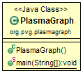

* 1. Package "org.pvg.plasmagraph.controllers"

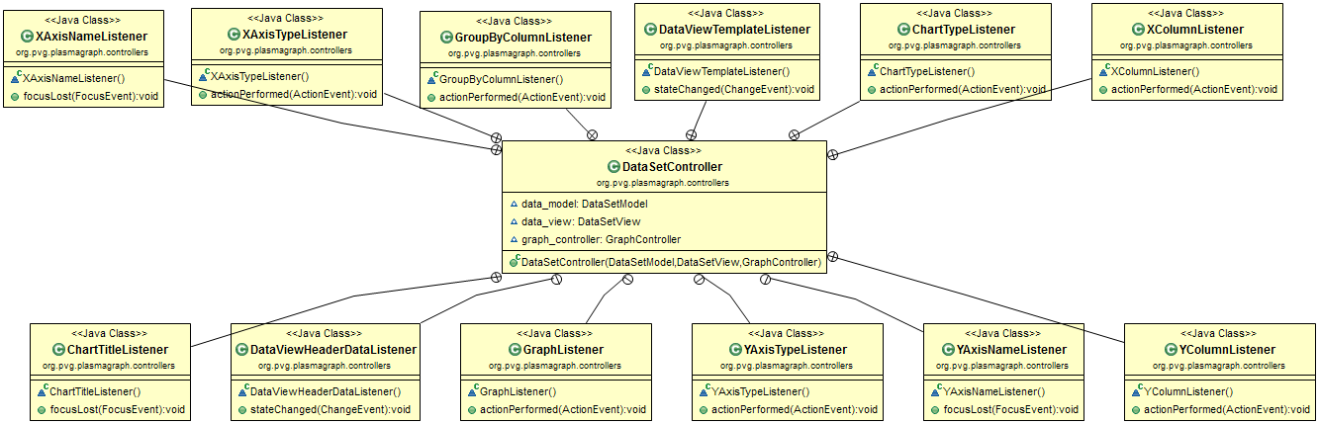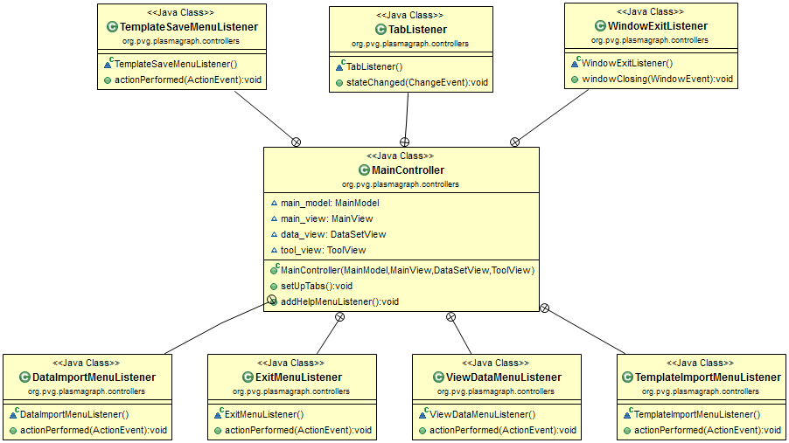Figure : "”org.pvg.plasmagraph.controllers” Package Contents

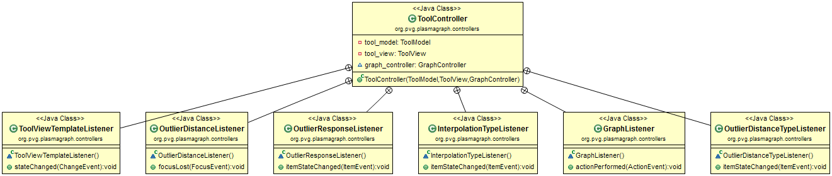

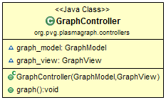

* 1. Package "org.pvg.plasmagraph.models"

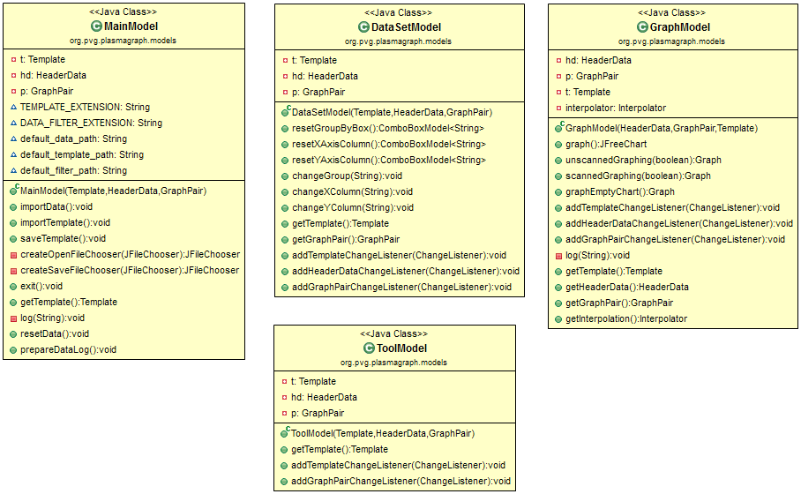Figure : "”org.pvg.plasmagraph.models” Package Contents

* 1. Package "org.pvg.plasmagraph.tests"

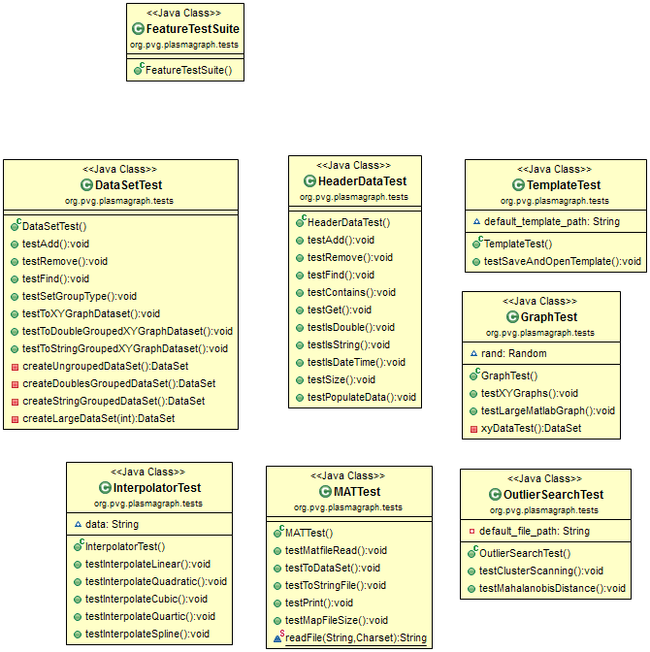Figure : "”org.pvg.plasmagraph.tests” Package Contents

* 1. Package "org.pvg.plasmagraph.utils"

Figure : "”org.pvg.plasmagraph.utils” Package Contents

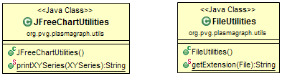

* 1. 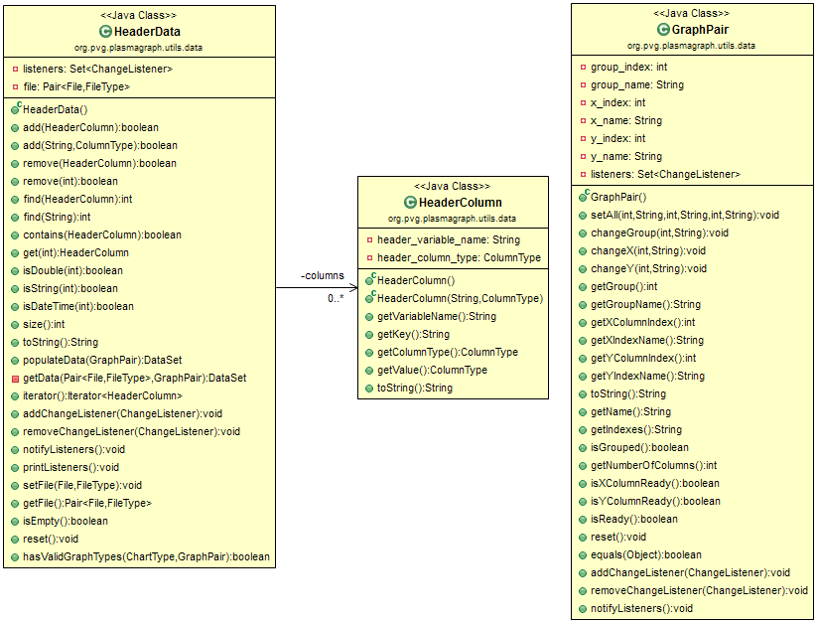Package "org.pvg.plasmagraph.utils.data"

Figure : "”org.pvg.plasmagraph.utils.data” Package Contents

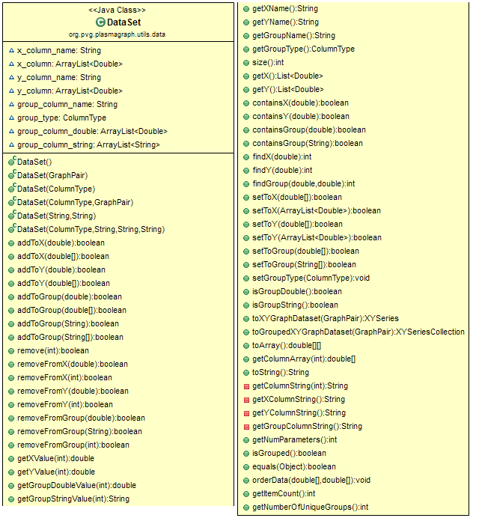

* 1. Package "org.pvg.plasmagraph.utils.data.readers"

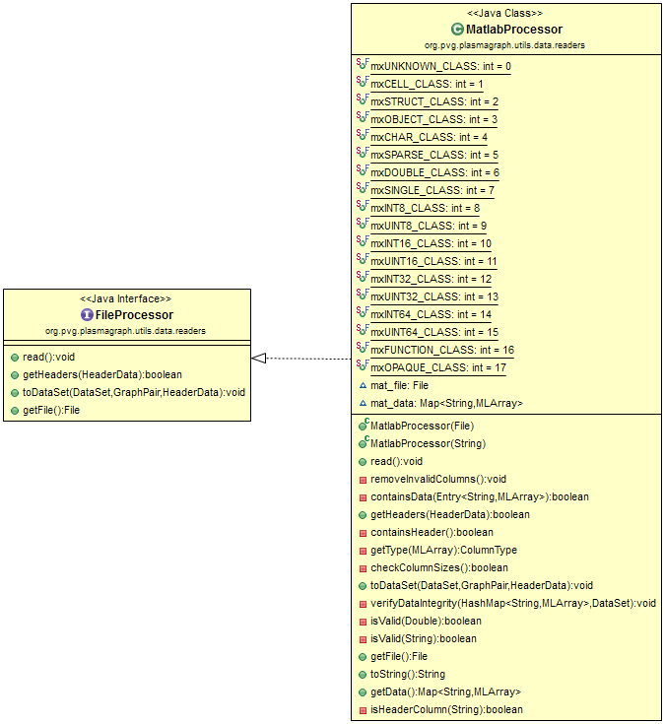Figure : "”org.pvg.plasmagraph.utils.data.readers” Package Contents

* 1. Package "org.pvg.plasmagraph.utils.graphs"

Figure : "”org.pvg.plasmagraph.utils.graphs” Package Contents

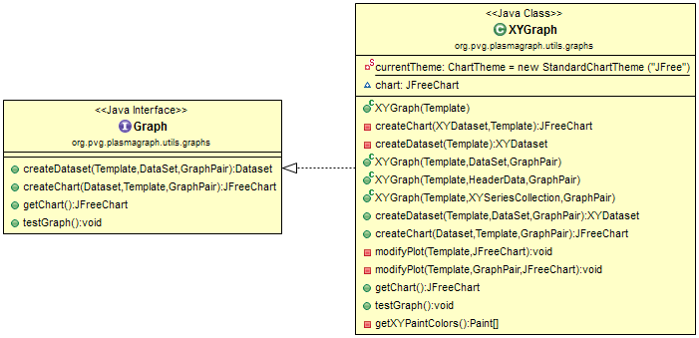

* 1. Package "org.pvg.plasmagraph.utils.template"

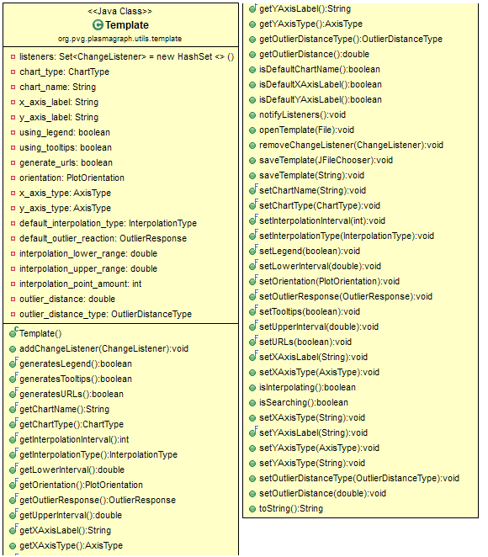Figure : “org.pvg.plasmagraph.utils.template” Package Contents

* 1. Package "org.pvg.plasmagraph.utils.tools"

Figure : "”org.pvg.plasmagraph.utils.tools” Package Contents

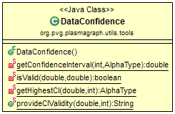

* 1. Package "org.pvg.plasmagraph.utils.tools.interpolation"

Figure : “org.pvg.plasmagraph.utils.interpolation” Package Contents

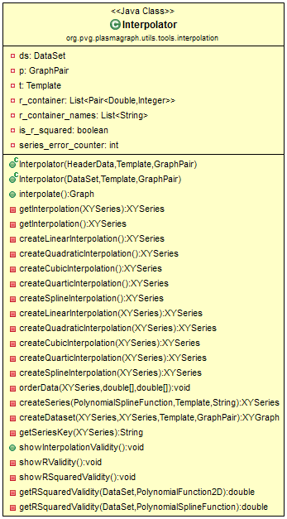

* 1. Package "org.pvg.plasmagraph.utils.tools.outlierscan"

Figure : “org.pvg.plasmagraph.utils.tools.outlierscan” Package Contents

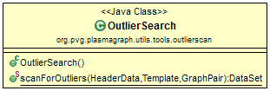

* 1. Package "org.pvg.plasmagraph.utils.tools.outlierscan.distances"

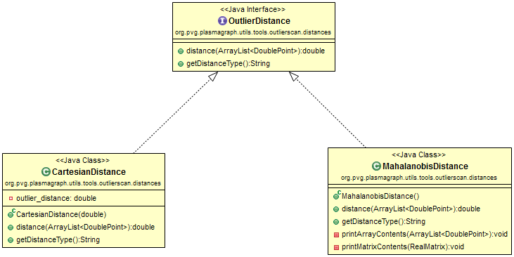Figure : “org.pvg.plasmagraph.utils.tools.outlierscan.distances” Package Contents

* 1. Package "org.pvg.plasmagraph.utils.tools.outlierscan.methods"

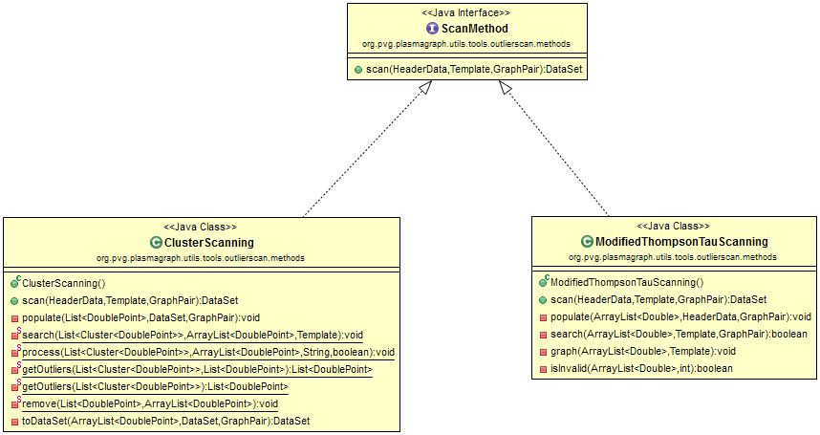Figure : “org.pvg.plasmagraph.utils.tools.outlierscan.methods” Package Contents

* 1. Package "org.pvg.plasmagraph.utils.tools.types"

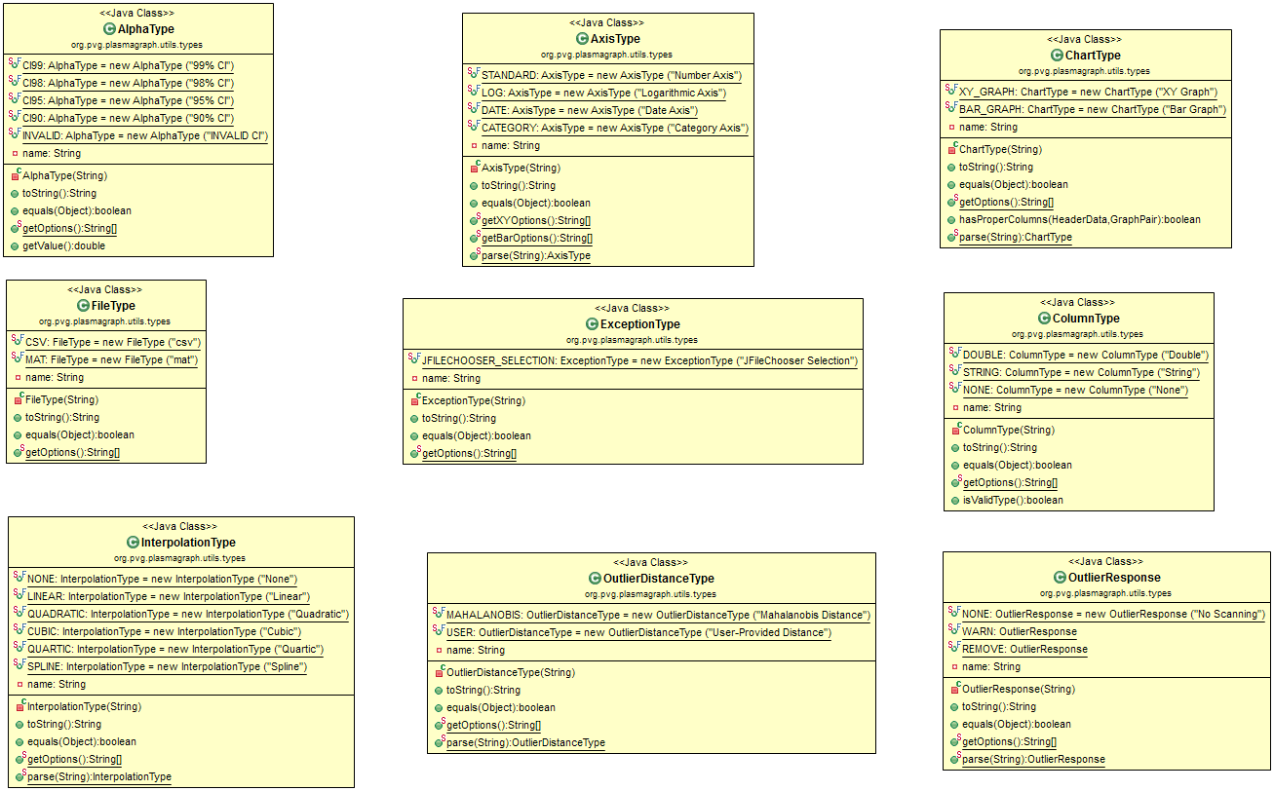Figure : “org.pvg.plasmagraph.utils.tools.types” Package Contents

* 1. Package "org.pvg.plasmagraph.views"

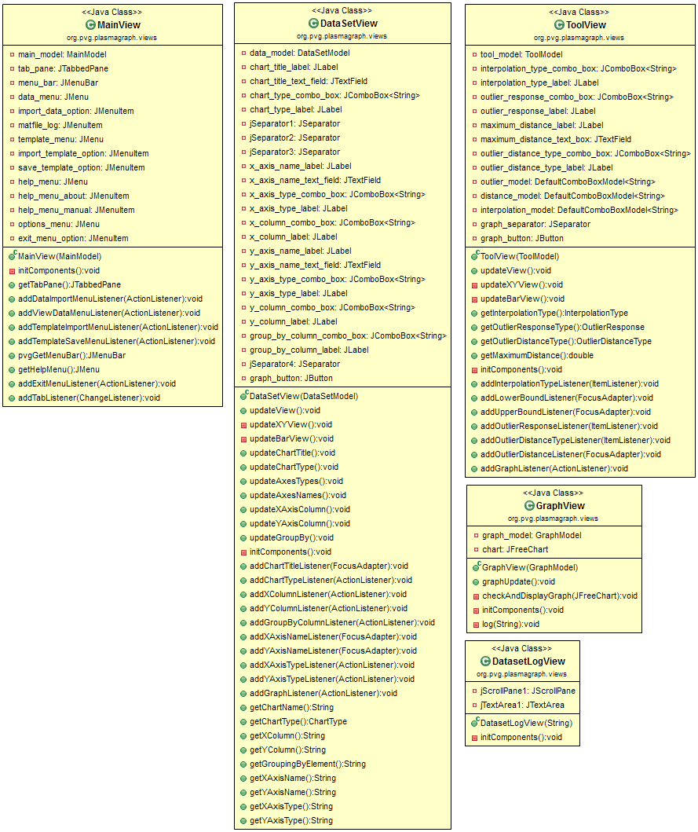Figure : “org.pvg.plasmagraph.utils.views” Package Contents

* 1. Package "HelpManual"

Figure : “HelpManual” Package Contents

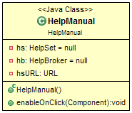

1. Requirement Fulfillment
2. Composition Diagrams

## 3.3 Design Rationale

PlasmaGraph has undergone many small changes from its initial design; the previous design was as follows:

* Derp
* Derp d
* Derp

As a result of the detractors of the previous design, the program was redesigned to accommodate for better utility.

* Herp
* Herph
* herp

These changes allowed the program to [TBD].

# 4. DATA DESIGN

## 4.1 Data Description

The data objects that will form a part of PlasmaGraph are:

* HeaderData (Located in: org.pvg.plasmagraph.utils.data)
* GraphPair (Located in: org.pvg.plasmagraph.utils.data)
* DataSet (Located in: org.pvg.plasmagraph.utils.data)
* Template (Located in: org.pvg.plasmagraph.utils.template)

These objects contain the data and settings required by PlasmaGraph in order to produce a graph. The following describes the purpose of each object in relation to furthering the program’s requirements as stated in the SRS.

* HeaderData: This object holds the user-provided data file’s location, as well as a list of the data file’s column names and column data types. This component can be combined with a GraphPair object to create a DataSet.
* GraphPair: This object contains the index references of the X, Y, and Group Columns, as well as their names. The GraphPair is a main component of all graphs, and allows for the easy creation of DataSets via its HeaderData column references.
* DataSet: The DataSet object is the synthesis of the HeaderData and GraphPair objects, containing the X, Y, and (if selected) Group Columns’ data. This object is used in conjunction with the Template to produce graphs.
* Template: The Template object is a container of any graph settings not derived from the data file itself. It is one of the two indispensable components (along with the GraphPair) of any PlasmaGraph graph.

Section 3.2 of this document details the underlying composition of these objects, and Section 5 details the processes by which these objects are combined to create graphs.

## 4.2 Data Dictionary

The list of data containers of the PlasmaGraph program and their attributes, methods, and parameters are as follows:

* DataSet
  + Attributes
  + Methods
* GraphPair
  + Attributes
  + Methods
* HeaderData
  + Attributes
  + Methods
* Template
  + Attributes
  + Methods

# 5. COMPONENT DESIGN

[TBD]

# 6. HUMAN INTERFACE DESIGN

## 6.1 Overview of User Interface

[TBD]

Describe the funct i onali t y o f the system from the user’s perspect ive. Explain how the user

will be able to use y our sy stem to complete all the expect ed f eatures and the feedback

inf ormat i on that will be displayed f or the user.

## 6.2 Screen Images

[TBD]

Di spla y screenshots showing the interface from the user’s perspect ive. These can be hand­

drawn or y ou can use an automated drawing too l. Just make them as accurate as possible.

(Graph paper works well.)

## 6.3 Screen Objects and Actions

[TBD]

A discussi o n of screen objects and act i ons associ ated wi th those obj ects.

# 7. REQUIREMENTS MATRIX

[TBD]

Provide a cross reference that traces components and data structures to he requirements in your SRS document .

Use a tabular format to show which system components sat i sfy each of the funct i onal

requi rements f rom the SRS. Ref er t o the f unct i onal requi rements by the numbers/codes that you gave them in the SRS.

# 8. APPENDICES

This section is optional